2019 Alumni Ambassador

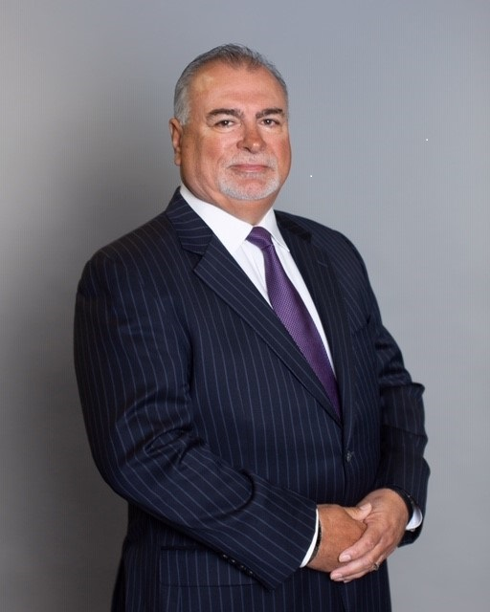

Dr. Gene Burton earned his master’s degree and his doctorate in Education Administration from Texas A&M University-Commerce.

His practical knowledge regarding the needs of public schools results from years of service in the Waxahachie ISD and the Frost and Giddings school districts. Dr. Burton worked for Rockwall ISD from 1994 to 2010, serving as the assistant superintendent for business operations, then as deputy superintendent and retired as superintendent.

Under Dr. Burton’s leadership, the district’s academic performance and financial health increased significantly. Dr. Burton was also instrumental in introducing character education initiatives, such as the nationally recognized Rachel’s Challenge program.

Dr. Burton served on many civic and community boards during his time as Rockwall Superintendent of Schools. He is past chairman and/or member of the Board of Directors of the Rockwall Economic Development Corporation, Rockwall Noon Rotary Club and Board of Directors for Lake Pointe Medical Center Hospital. Dr. Burton also played the prominent role in forming the Rockwall Independent School District Educational Foundation, Inc.

Dr. Burton has one daughter, Cecilia and a son-in-law, Jesse who have three children. He enjoys golfing with his wife, Julie. Dr. Burton currently serves as a consultant for Pogue Construction and volunteers for Rachel’s Challenge.

